**ESTIMATION OF BUSINESS EXPENSES**

**Team id: nm2023tmid05858**

**A project report**

**Submitted by**

**M.AKASH 222105256**

**m.heerusah 222105263**

**r.ramanan 222105268**

**p.praveenkumar 222105266**

**project incharge :**

**DR.r.k.SUGANTHI**

**ASSISTANT PROFESSOR**

**DEPARTMENT OF MATHEMATICS SIR THEAGARAYA COLLEGE**

**CHENNAI-21**



**estimation of business expenses**

**team id :nm2023tmid05858**

**a project report**

**Submitted by**

**m.akash asunm1325222105256**

**m.heerusah asunm1325222105263**

**r.ramanan asunm1325222105268**

**p.praveenkumar asunm1325222105266**

**project incharge :**

**Dr.R.K.SUGANTHI**

**ASSISTANT PROFESSOR**

**DEPARTMENT OF MATHEMATICS SIR THEAGARAYA COLLEGE**

**CHENNAI-21**



|  |  |  |
| --- | --- | --- |
| **CHAPTER**  **NO** | **TOPIC** | **PAGE**  **NO** |
| 1. | INTRODUCTION | 4 |
| 2. | Problem definition & design thinking | 7 |
| 3. | result | 11 |
| 4. | Advantages & disadvantages | 15 |
| 5. | applications | 16 |
| 6. | conclusion | 17 |
| 7. | Future scope | 18 |

**CONTENTS**

**1.InTroduction :**

**Estimation Of Business Expenses**

**This report deal's into the fascinating realm of business expenses and provides a visual exploration of the various expenditures incurred by different businesses. It showcases the distribution of expenses, identifies key cost drivers, and highlights areas of potential optimization or concern. The visual representations allow for intuitive analysis, facilitating a deeper understanding of expenditure patterns and their implications for business performance. Decision-makers, financial analysts, and stakeholders can gain valuable insights into the financial health of businesses, identify areas of inefficiency or opportunity, and make informed decisions to optimize resources and drive growth. To Extract the Insights from the data and put the data in the form of visualizations, Dashboards and Story we employed Tableau tool.**

**Technical Architecture:**

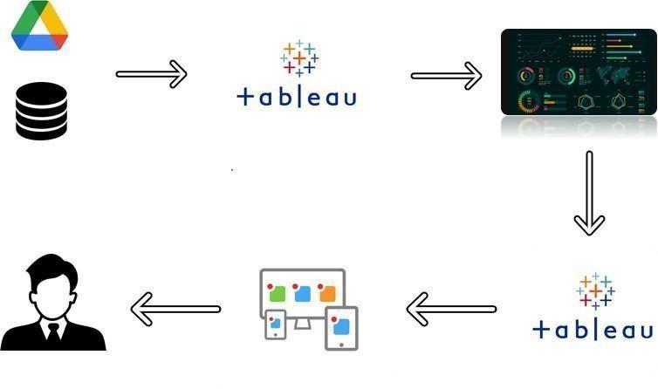

**overview:**

**1. INTRODUCTION**

**A brief description about the project titled “ Estimation of business expenses ”.**

* 1. **Purpose**

**The use of this project has been discussed and its Application.**

**2. Problem Definition & Design Thinking**

**2.1 Empathy Map**

Empathizing the perspective of user and giving it in visualization form.

**2.2 Ideation & Brainstorming Map**

**Generating and organizing ideas in a structured and in visual way.**

**3.RESULT**

**Final findings (Output) of the project has been projected using screenshots of dashboard and story.**

**4. ADVANTAGES & DISADVANTAGES**

**List of advantages and disadvantages of the proposed solution.**

**5. APPLICATIONS**

**Explaining the areas where this solution can be applied in effective way.**

**6. CONCLUSION**

**Summarizing the entire work and findings of the proposed problem.**

**7. FUTURE SCOPE**

**Enhancements that can be made in the project for future study.**

* 1. **Purpose:**

**Estimating business expenses supports effective budgeting, enhances financial foresight, facilitates resource allocation, manages risks, and aids decision-making.**

**2.PROBLEM DEFINITION & DESIGN THINKING**

* 1. **Empathy Map**

**An Empathy Map is a tool used to help understand and empathize with the perspective of a particular user or customer. It is a visual representation of the user's attitudes, behaviors, emotions, and experiences that can be used to gain a deeper understanding of their needs and motivations The Empathy Map is typically divided into four quadrants "Says," "Thinks," "Does," and "Feels." In each quadrant, the user's thoughts, feelings, actions, and spoken words are recorded to help build a more complete understanding of their perspective. The Empathy Map is often used in design thinking and user experience research to help inform the design of products or services that better meet the needs of the user.**

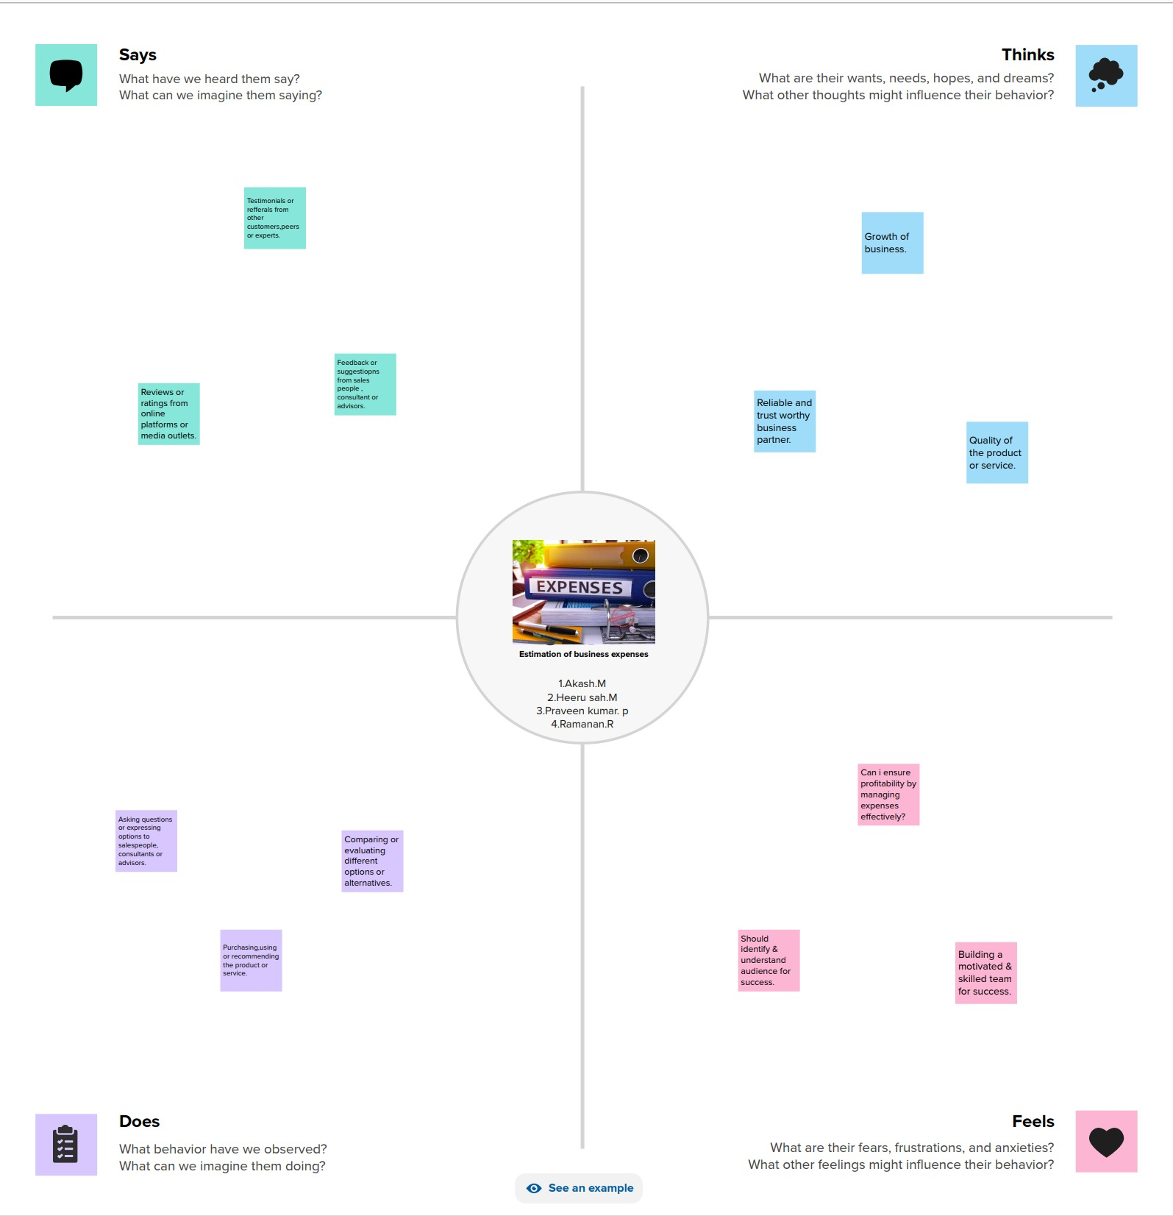

**2.2. IDEATION & BRAINSTORMING MAP:**

1. **Ideation and Brainstorming Maps are tools used to generate and organize ideas in a structured and visual way. They are commonly used in creative problem solving, innovation, and product design to generate a large number of ideas and then organize them into meaningful categories.**
2. **Ideation and Brainstorming Maps typically start with a central theme or problem statement in the center of the map. From there, branches are drawn out to represent different categories or subtopics related to the central theme. These categories can then be further expanded with additional branches to represent specific ideas.**
3. **The purpose of an Ideation and Brainstorming Map is to encourage free thinking and generate as many ideas as possible. It allows participants to visually see how ideas are connected and to build upon each other's ideas. The map can then be used to prioritize and refine the most promising ideas. There are many variations of Ideation and Brainstorming Maps, including Mind Maps. Spider Maps, and Fishbone Diagrams.**

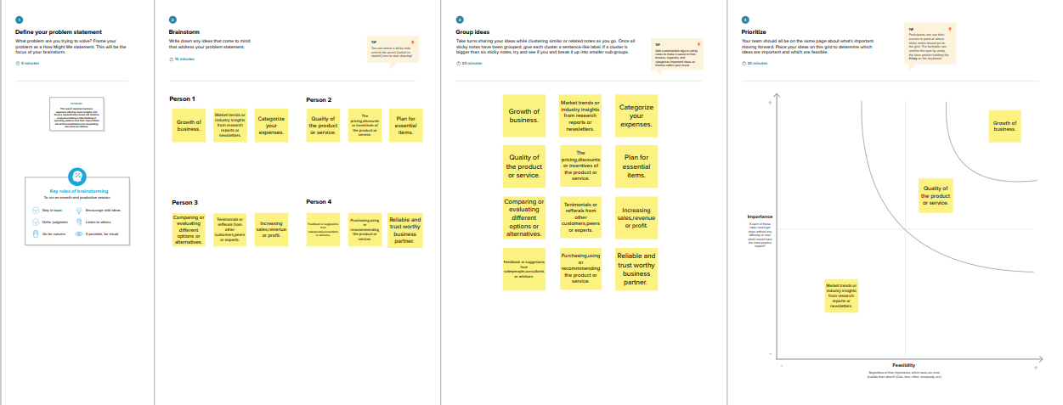

**3.RESULTS:**

**3.1 DASHBOARD:**

**Creating a Dashboard in Tableau:**

* **A dashboard is a collection of different kinds of visualizations or views that we create on Tableau We can bring together different elements of multiple worksheets and put them on a single dashboard.**
* **The dashboard option enables us to import and add charts and graphs from worksheets to create a dashboard. On a dashboard, we can place relevant charts and graphs in one view and analyze them for better insights..**

**DASHBOARD 1**

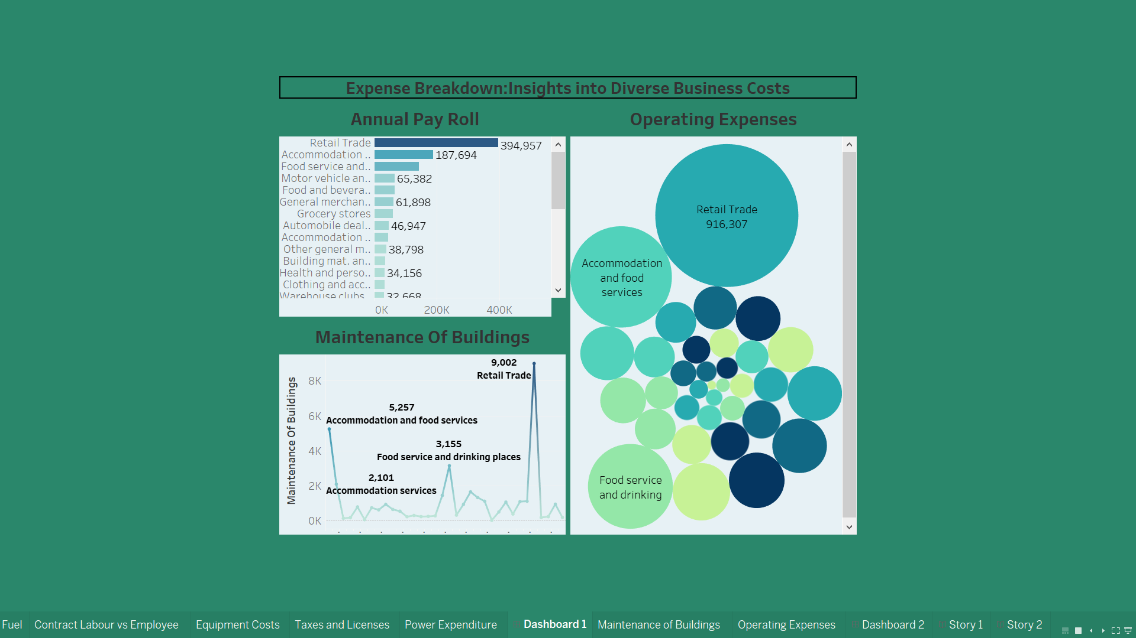

**DASHBOARD 2**

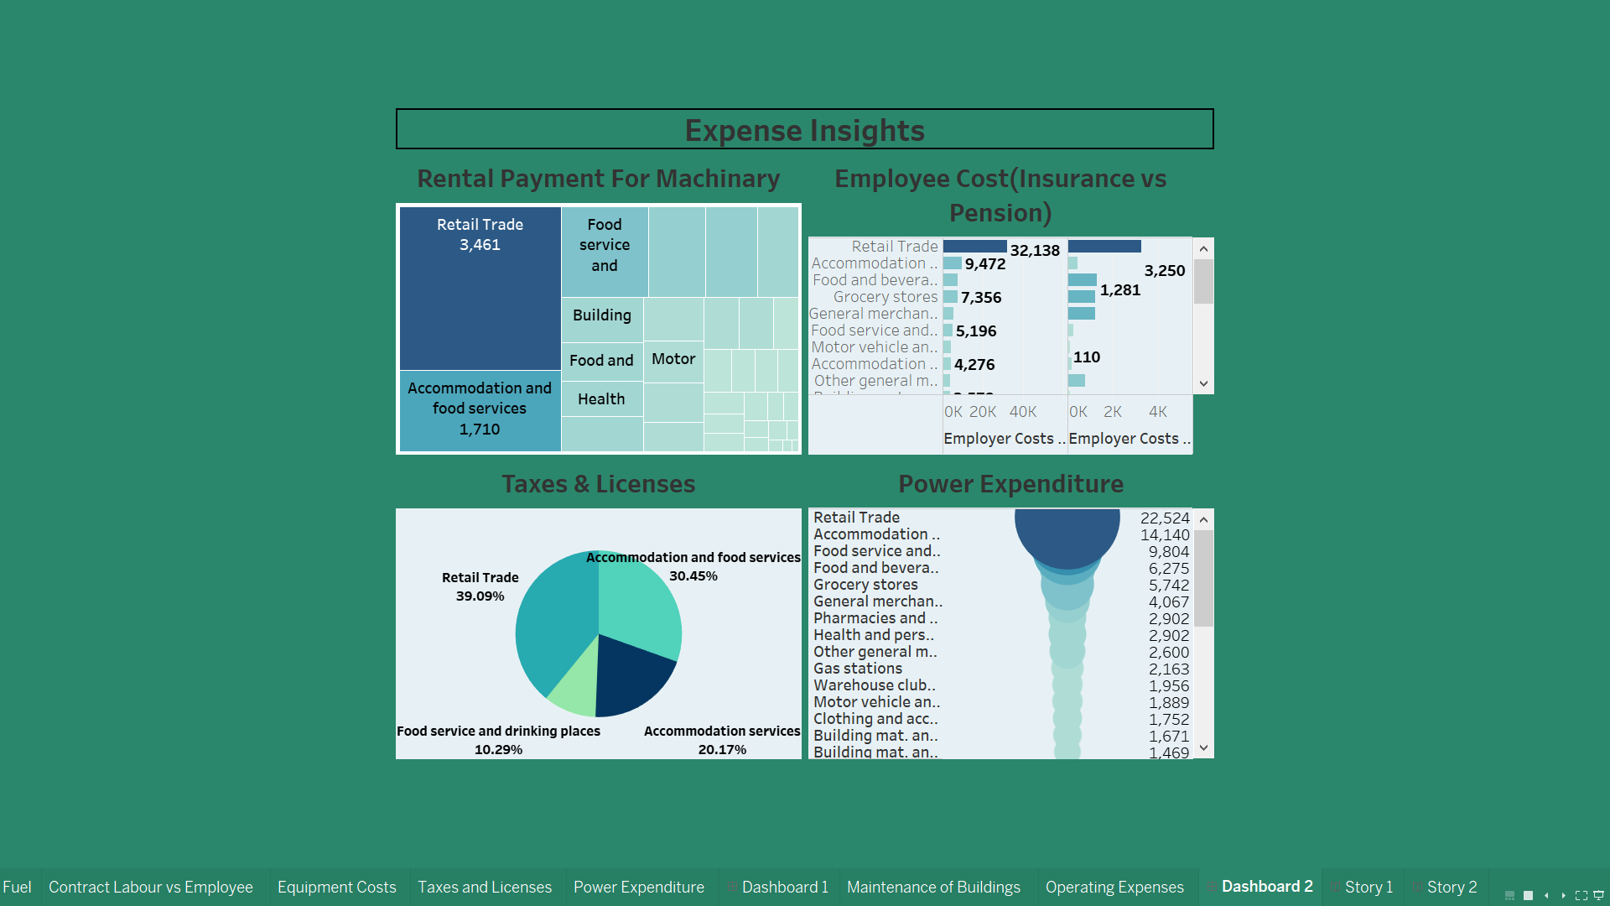

**3.2 STORIES:**

**What are Tableau Stories?**

**Well, it is a sequence of different charts that combine to provide cohesive plot to its viewers In essence, all these charts tell a day about the data which allows the viewers to form the conclusion. The story in Tableau contains story points, where each story point is either a work or a dashboard.**

**When you share a story-for example by publishing a workbook to Tableau Public, Tableau Server, or Tableau Clad-users can interact with the story to reveal new findings or ask new questions of the data.**

**A. Options For Adding A New Story Point: Choose Blank to add a new point or Duplicate to use the current story point as the starting place for your next point.**

**B. The Story Pane: Use this pane to drag dashboards, sheets, and test descriptions to your story sheet. This is also where you set the size of your story and display or hide the title.**

**C. The Layout Pane: This is where you choose your navigator style, and display or hide the forward and back arrows.**

**D. The Story Menu: Use this menu in Tableau Desktop to format the story or copy or export the current story point as an image. You can also clear the entire story here or show or hide the navigator and story title.**

**E. The Story toolbar: This toolbar appears when you mouse-over the navigator area. Use it to revert changes, apply updates to a story point. delete a story point, or create a new story point out of the current, customized one.**

**F. The navigator: The navigator allows you to edit and organize your story points. It's also how your audience will step through your story. To change the style of the navigator, use the Layout pane.**

**STORY 1**

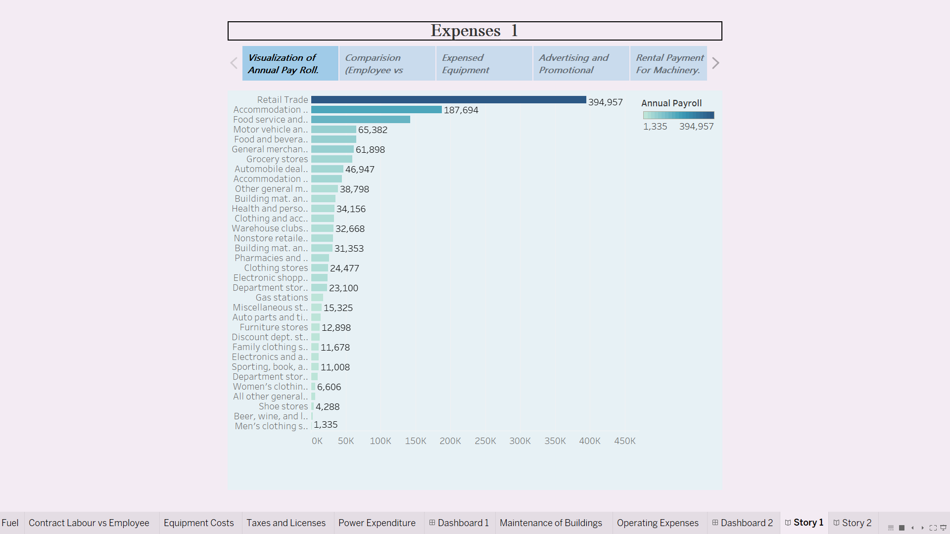

**STORY 2**

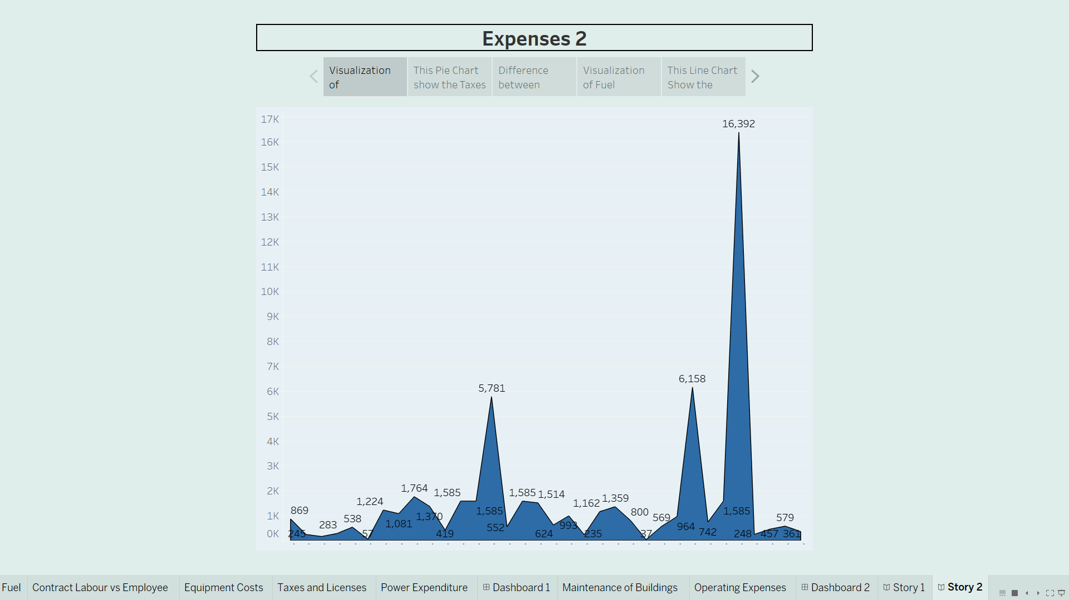

**4.Advantages& Disadvantages:**

**Advantages:**

1. Financial Planning: Enables effective budgeting and allocation of resources.
2. Cost Control: Identifies areas for potential cost savings and efficiency improvements.
3. Profitability: Helps maintain healthy profit margins by understanding and managing expenses.

**Disadvantages:**

1. Inaccuracy: Estimations may be imprecise, leading to financial challenges.
2. Missed Opportunities: Overlooking certain expenses may hinder strategic investments and growth.
3. Static Nature: Business conditions can change, and static estimates may become outdated quickly.

**5.APPLICATIONS:**

**1. Budgeting: Guides the allocation of financial resources for various business activities.**

**2. Investment Planning: Assists in determining the feasibility of new projects are ventures.**

**3. Forecasting: Provides insights into future financial needs and potential challenges.**

**4. Decision-Making: Informs strategic decisions by considering the financial impact.**

**5. Performance Evaluation: Facilitates the comparison of estimated vs. actual expenses for performance assessment.**

**6. Risk Management: Identifies potential financial risks and allows for proactive risk mitigation.**

**7. Negotiations: provides a basis for negotiating contracts and agreements with suppliers or service providers.**

**8. Tax Planning: Helps in estimating and planning for tax obligations accurately.**

**9. Resource Allocation: Ensures efficient allocation of resources to optimize productivity.**

**10. Funding Requests: Supports funding requests by presenting a clear picture of financial needs.**

**6.CONCLUSION:**

**Analyze of estimation of business expenses is done in this project.**

**We analyzed the given data and we conclude that the most expensive top 2 business type is 1. Retail trade.**

**2. Accommodation and Food Services.**

**7. FUTURE SCOPE:**

**The current project did not deal with cost control effects which plays a major role in Business. In our future work, we will add this for further analysis.**

1. **Advanced Analytics: Integration with advanced analytics and artificial intelligence for more accurate predictions.**
2. **Real-Time Estimation: Development of systems allowing real-time updates and adjustments to expense estimates.**
3. **Blockchain Integration: Utilizing blockchain for transparent and secure tracking of financial transactions and expenses.**
4. **Predictive Technologies: Leveraging predictive technologies to anticipate future expenses based on historical data and market trends.**
5. **Machine Learning Algorithms: Implementation of machine learning algorithms to continuously improve the accuracy of expense predictions.**
6. **Globalization Challenges: Addressing complexities in estimating expenses in a globalized business environment with diverse currencies and regulations.**
7. **Integration With IoT: Connecting with the internet of Things (IoT) devices for automated expense tracking and data collection.**
8. **Sustainability Metrics: Incorporating estimations for sustainability-related expenses as businesses focus more on environmental and social responsibility.**
9. **Customization: Tailoring estimation models to specific industry nuances and business models.**
10. **Collaborative Tools: Developing collaborative tools that allow different departments to contribute to and validate expense estimates in a streamlined manner.**